

**BAHRIA UNIVERSITY LAHORE CAMPUS**

SPRING 2025

**Course Title: Entrepreneurship – HSS 410**

**Final Project**

|  |  |  |  |  |  |
| --- | --- | --- | --- | --- | --- |
| Course Instructor: **Muhammad Raheel Iqbal Butt** | | | | | |
| Section: **A** | | Program: **BS IT** | | Date: **March 10, 2025** | |
| Submission Date: **May 25, 2025** | | | Maximum Marks: **20** | | |
| Program Objective: **PO1, PO2** | Course Objective: **CO1, CO2,** | | | | Course Learning Objective: **CLO1, CLO2** |
| **TO BE FILLED IN BY THE STUDENT** | | | | | |
| Student Name: Registration No: Group  1: Arooba Mansoor 03-135231-009  2: M. Adil Aslam 03-135231-052 **D**  3: M. Zain Shabir 03-135231-031 | | | | | |
| Marks Obtained : | | | | | |
| Mentor Remarks & Signature:  Signature | | | | | |
| Resource Person Remarks & Signature:  Signature | | | | | |



ArOOBA mANSOOR

M. adil Aslam

M.zain shabhir

**STORE eASE**

**Bahria University Lahore Campus**

May 25, 2025

eNTREPRENEURSHIP PROJECT

Table of Contents

Part I: Store Ease-Market Research Analysis 4

1. Customer Analysis 4

2. Competitor Analysis 5

3. Industry Analysis 6

4. SWOT Analysis 7

Part II: StoreEase - Business Model Development 9

How create, deliver and capture Value 9

How to Create Value 9

How to deliver Value 10

Capture Value 10

Business Model Canvas Summary 11

Part III: Resource Assessment – *StoreEase* 13

Resource Requirements 13

A. Physical Resources 13

B. Technology Infrastructure 14

C. Operational Setup 14

D. Human Resources 14

E. Financial Resources 14

**Total Investment Summary** 15

2. Resource Acquisition Plan 16

A. Funding Options 16

B. Potential Partners 17

Part IV: Marketing Plan – StoreEase 18

1. Target Market Segmentation 18

A. Students (Age: 18–24) 19

B. Hostel Residents (Age: 18–26) 19

C. Travelers (Age: 25–40) 19

2. Marketing Strategies 19

A. Digital Marketing 19

B. Conventional Marketing 20

3. Branding Strategy 20

A. Brand Personality 20

B. Brand Positioning 20

C. Brand Message 20

D. Visual Identity 21

E. Strategic Alignment 21

Part V: Operations Plan – StoreEase 21

1. Production/Service Delivery Process 21

Step-by-Step Service Delivery Process 21

Potential Bottlenecks & Challenges 22

2. Supply Chain Management 23

**Supply Chain Structure** 23

Sourcing & Distribution Process 23

Potential Supply Chain Risks & Solutions 23

3. Customer Service Strategy 24

Customer Service Standards 24

Feedback & Support Channels 24

Customer Satisfaction & Retention Tactics 24

Part VI: Financial Projections (Simplified) – *StoreEase* 26

1. Revenue Forecasts (First Year) 26

**Service Lines and Channels** 26

**Estimated Monthly Revenue Breakdown** 27

**Total Projected First-Year Revenue** 27

2. Expense Budget (First Year) 28

**Fixed Costs** 28

**Variable Costs** 28

**Total Projected Expenses for Year 1** 29

3. Break-even Analysis 30

**Break-even Point Calculation** 30

**Time to Reach Break-even** 30

**Tactics to Achieve Break-even** 30

References 31

# Part I: Store Ease-Market Research Analysis

## 1. Customer Analysis

**Real-Life Potential Customers**

**Students (e.g., Bahria University, FC College)**

* Carry laptops, notes, and personal items daily
* Face inconvenience during short breaks/lunch hours due to lack of secure space
* Don’t have access to formal locker systems on campus  
  **Need:** Hourly or daily secure locker access **on campus**

**Hostelers (e.g., Students from remote areas)**

* Must vacate hostels during semester/summer breaks
* Often pay room rent even during summer breaks or transport items back home, which is costly  
  **Need:** Monthly, affordable, and secure storage near hostels

**Travelers (Domestic tourists visiting Lahore, Islamabad, etc.)**

* Experience gaps between hotel checkout (e.g., 11 AM) and travel time (e.g., 6 PM)
* Carry luggage throughout the day due to lack of flexible storage  
  **Need:** Hourly or daily storage at key locations (e.g., bus stations, malls, hotels)

**Percentage of Potential customers according to segments:**

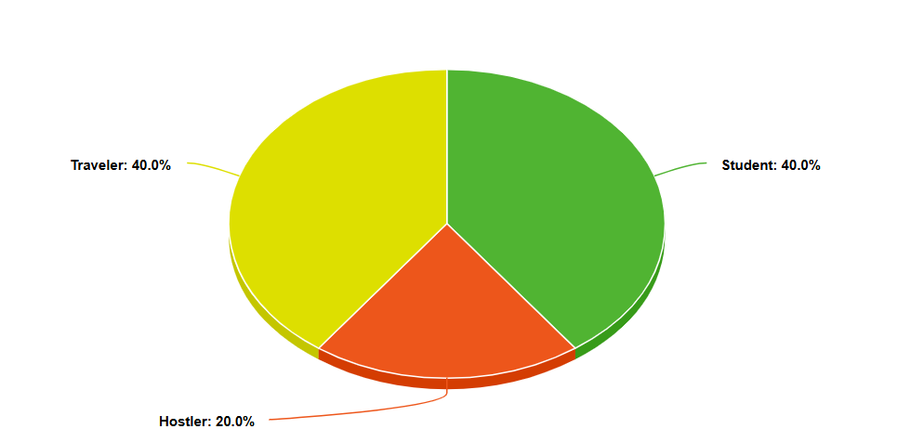

**What These Customers Prefer**

* **Safety:** No risk of theft or mishandling
* **Convenience:** Easily bookable via **mobile app/Website**
* **Flexible Timings:** From 1-hour to 3 or 6-months
* **Affordability:** Low daily/monthly rates for students and tourists
* **Digital Experience:** Smart lockers, QR access, real-time notifications

**How StoreEase Meets Their Needs**

* **24/7 Security** with biometric access, smart lockers, and CCTV
* **Mobile App** to book, pay, and manage storage via smartphone
* **Hourly/Daily/Monthly Packages** to fit exact duration needs
* **Strategic Locations** in university campuses, hostels, and tourist hubs
* **Insurance & Receipts** for peace of mind)

[**[1]**](https://eusafeluggage.com/luggage-storage-security-tips/)

## 2. Competitor Analysis

**Existing Informal Competitors (Per Segment)**

| **Segment** | **Current Alternative** | **Gaps** |
| --- | --- | --- |
| **Students** | Leave bags in class or friends’ rooms | Unsecure, no liability |
| **Hostelers** | Hostel common rooms / take items home | Manual, expensive, no insurance |
| **Travelers** | Hotel lobbies or extended bookings | Not always available, costly, not designed for luggage |

**StoreEase’s Edge**

| **Feature** | **StoreEase** | **Existing Options** |
| --- | --- | --- |
| Smart Lockers | Yes | No |
| QR/Biometric Access | Yes | No |
| Hourly/Daily Bookings | Yes | No |
| App-Based Booking | Yes | No |

[[2]](https://london-post.co.uk/why-luggage-storage-services-are-the-future-of-travel/)

## 3. Industry Analysis

**Industry Overview – Pakistan**

* Pakistan’s **temporary storage and warehousing industry** is growing at **15% annually** due to tourism and digital adoption [[3]](https://www.6wresearch.com/)
* The **e-commerce boom** adds pressure to existing storage infrastructure
* Students & tourists are core consumers of **short-term, app-based services**

**Trends & Opportunities**

| **Trend** | **Opportunity** |
| --- | --- |
| Smartphone penetration among youth | App-based solutions are highly accessible [[4]](https://www.pta.gov.pk/en/telecom-indicators) |
| Tourism revival post-COVID | Hourly luggage storage in demand [[5]](https://www.unbaggaged.com/post/safest-luggage-storage-service-tips) |
| Academic schedules with summer/winter hostel closures | Recurring need for semester-based storage |
| Urbanization & shared spaces | Demand for flexible, localized storage |

**Local Relevance**

* Over **20,000 students** face storage challenges during breaks in Lahore alone [[6]](https://www.fccollege.edu.pk/)
* Tourist footfall in Northern Pakistan exceeds **10,000 travelers per month** [[7]](https://www.thenews.com.pk/)

**The timeline graph of storage needs peaks:**

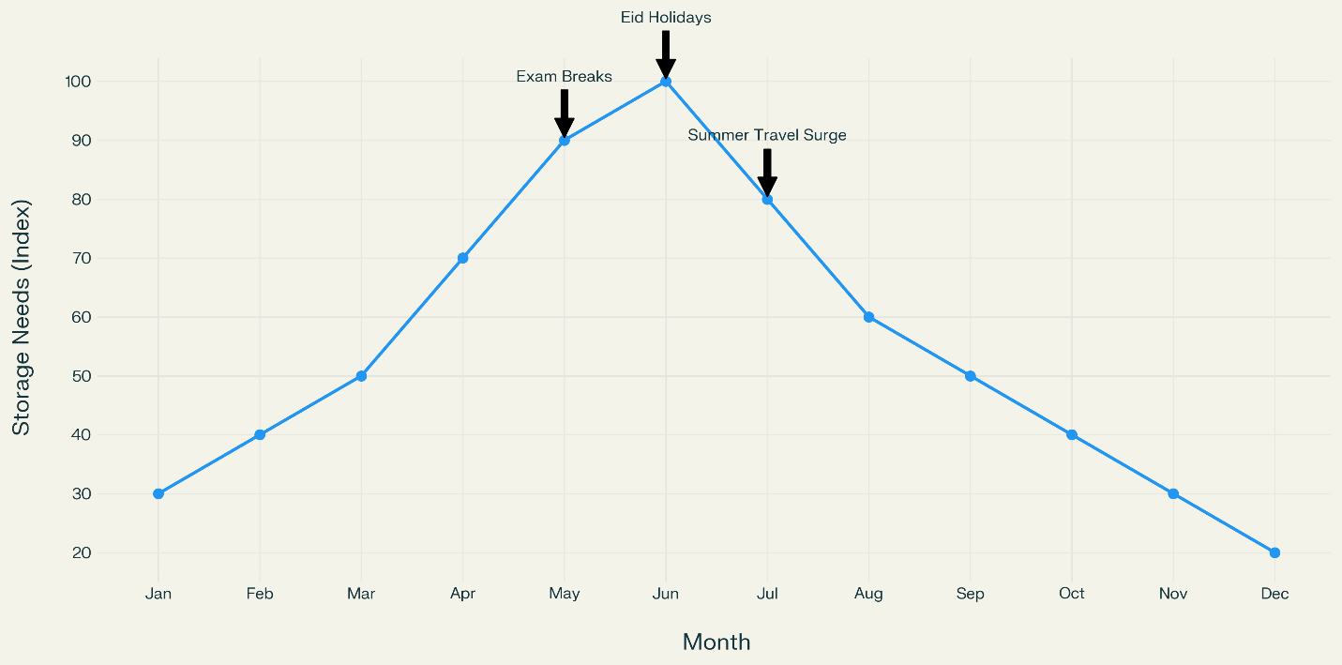

## 4. SWOT Analysis

**Strengths**

* Tech-driven, AI-powered, secure lockers
* Directly addresses underserved segments: students, hostelers, and tourists
* Scalable **asset-light** business model
* Trusted locations via partnerships with universities and hotels

**Weaknesses**

* Brand awareness is low (new startup)
* No physical infrastructure owned
* App development and management cost
* Relies on **external approvals (e.g., NOCs from university administration)**

**Opportunities**

* Rapid growth in domestic tourism
* Smartphone usage among students and travelers rising
* Institutional partnerships can provide instant trust and access

**Threats**

* Copycat startups entering with similar models
* Institutional resistance or bureaucratic delays
* Tech reliability (if the app crashes or lockers malfunction)

**Strategic Implications**

* **Leverage Strengths:** Position StoreEase as a secure, student-first tech solution on digital platforms
* **Fix Weaknesses:** Partner with universities to get endorsements and physical access
* **Exploit Opportunities:** Start with student-focused pilot, then expand to tourist-heavy areas
* **Defend from Threats:** Patent the tech, offer insurance, maintain high customer satisfaction

**SWOT Matrix Infographic:**

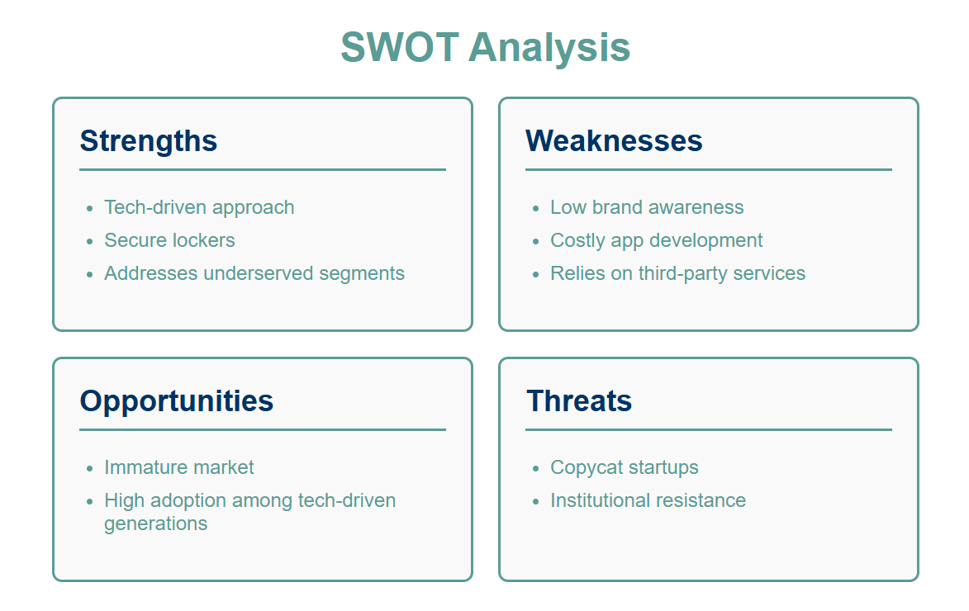

# Part II: StoreEase - Business Model Development

## How create, deliver and capture Value

### How to Create Value

StoreEase creates value by solving real problems for travelers, students, and hostelers who need **safe, flexible, and affordable temporary storage**. We use technology and partnerships to make the storage experience easy and trustworthy.

* **Secure Storage:** Providing lockers and units with 24/7 CCTV and insurance options ensures customer belongings are safe.
* **Convenient Access:** A user-friendly mobile app allows customers to book, pay, and access storage easily using QR codes.
* **Flexible Options:** Customers can choose storage time and size that fit their needs — from a few hours to several months.
* **Multiple Locations:** By partnering with hostels, hotels, and commercial hubs, StoreEase offers storage close to where customers need it.

[**[1]**](https://eusafeluggage.com/luggage-storage-security-tips/)

### How to deliver Value

StoreEase delivers this value through:

* **Digital Platform:** Our mobile app and website provide seamless booking, payment, and real-time tracking.
* **Physical Infrastructure:** Strategically placed storage units in high-traffic, convenient locations.
* **Customer Support:** 24/7 assistance through chatbots and human agents ensures help is always available.
* **Partnerships:** Collaborations with hotels, hostels, local space owners, and logistics providers expand reach and enhance convenience.
* **Transparency and Security:** Digital confirmations, inventory records, and insurance build customer trust and peace of mind.

### Capture Value

Store Ease captures value by generating revenue and building customer loyalty through:

* **Rental Fees:** Charging customers daily or monthly fees based on the size and duration of storage.
* **Premium Services:** Offering add-ons like insurance coverage and larger or specialized lockers at higher prices(for later).
* **Partnership Revenue:** Earning commissions or fees from partner businesses (hotels, hostels) that refer customers or host storage units.
* **Customer Retention:** Encouraging repeat business through loyalty discounts, referral rewards, and regular communication.
* **Cost Efficiency:** Using technology to automate bookings and reduce staffing costs improves profitability.

[[2]](https://london-post.co.uk/why-luggage-storage-services-are-the-future-of-travel/)

## Business Model Canvas Summary

**1. Customer Segments:**

* Students
* Hostelers
* Travelers

**2. Value Proposition:**

* Safe, flexible, accessible storage
* Smart booking via app
* Affordable packages

**3. Channels:**

* Mobile app
* Website
* Social media
* Partner locations

**4. Customer Relationships:**

* 24/7 support
* Loyalty and referral programs

**5. Revenue Streams:**

* Rental fees
* Premium add-ons
* Partner commissions

**6. Key Resources:**

* App and tech
* Smart lockers
* Security systems

**7. Key Activities:**

* App maintenance
* Booking management
* Partner coordination

**8. Key Partnerships:**

* Hotels and hostels
* IT and logistics vendors

**9. Cost Structure:**

* App development
* Locker rental or purchase
* Marketing and staffing
* Security infrastructure

**Business Model Canvas Visual**

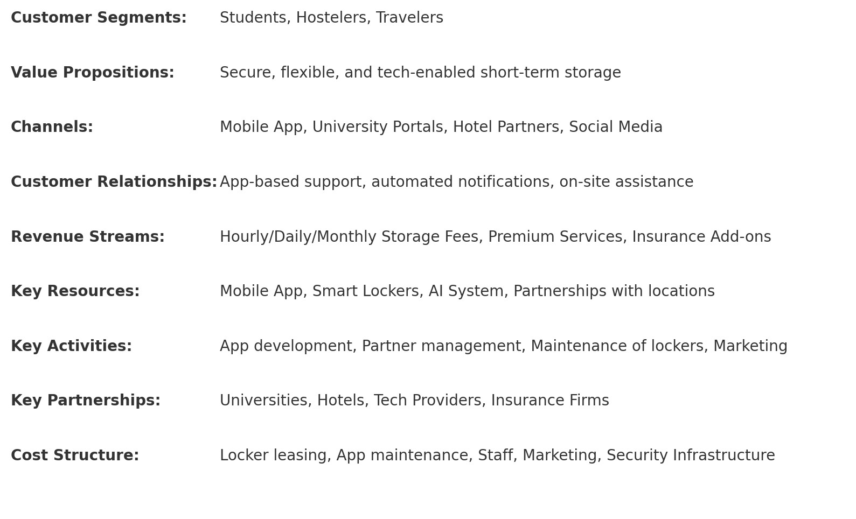

# Part III: Resource Assessment – *StoreEase*

## Resource Requirements

### A. Physical Resources

| **Resource** | **Details** | **Estimated Cost** |
| --- | --- | --- |
| Smart Lockers | QR/Biometric-enabled lockers (10 units) | PKR 150,000 – 250,000  [[8]](https://www.camcode.com/blog/types-of-warehouse-storage-systems/) |
| Portable Storage Containers | 5 large mobile containers | PKR 500,000 – 1,000,000 [[9]](https://ibrahimportacabin.pk/container-for-rent/) |
| CCTV & Sensors | Cameras and basic monitoring | PKR 150,000 [**[1]**](https://eusafeluggage.com/luggage-storage-security-tips/) |

### B. Technology Infrastructure

| **Resource** | **Description** | **Estimated Cost** |
| --- | --- | --- |
| Mobile App Development | Cross-platform iOS/Android + backend | PKR 800,000 – 1,200,000 |
| Website Development | For customer access and admin | PKR 200,000 – 300,000 [[10]](https://boostsuite.com/launching-storage-business/) |
| Cloud Hosting | AWS, Google Cloud, backup | PKR 25,000/month [[11]](https://www.pcmag.com/picks/the-best-business-cloud-storage-and-file-sharing-providers) |
| AI Security/Analytics | Predictive and fraud detection | PKR 500,000 – 800,000 [[12]](https://www.advisoryexcellence.com/warehousing-on-demand-the-benefits-of-temporary-storage-solutions/) |

### C. Operational Setup

| **Resource** | **Description** | **Monthly/Annual Cost** |
| --- | --- | --- |
| Location Lease | Bahria University pilot site | PKR 50,000/month [[13]](https://bahria.edu.pk/) |
| Office Space | Co-working or small leased space | PKR 60,000/month [[14]](https://coworker.com/) |
| Utilities | Power, internet, water | PKR 25,000/month [[15]](https://www.pitb.gov.pk/) |
| Insurance | Damage, loss, liability | PKR 100,000/year |

### D. Human Resources

| **Role** | **Monthly Cost** |
| --- | --- |
| Technical Lead | PKR 120,000 |
| Operations Manager | PKR 90,000 |
| Marketing Specialist | PKR 80,000 |
| 2 Customer Service Reps | PKR 50,000 each |
| Security Guard | PKR 30,000 |
| Maintenance | PKR 25,000 |
| Finance (Part-Time) | PKR 60,000 |

### E. Financial Resources

| **Category** | **Amount** |
| --- | --- |
| Startup Capital | PKR 3 – 4 million |
| Working Capital (6 months) | PKR 2.5 million |
| Emergency Fund | PKR 1 million |
| Monthly Operational Cost | PKR 835,000 |

**% share of total investment (tech, HR, physical, ops):**

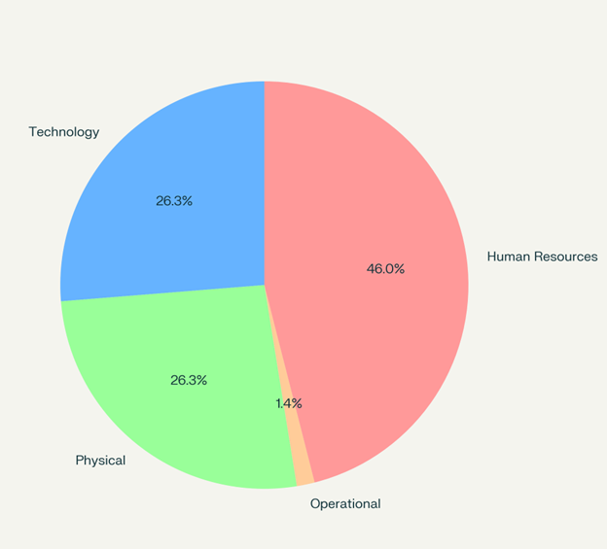

**Total Investment Summary**

* **Initial Investment**: PKR 6.5 – 7.5 million
* **Monthly Costs**: PKR 835,000

**Resource categories vs. cost (initial vs. monthly):**

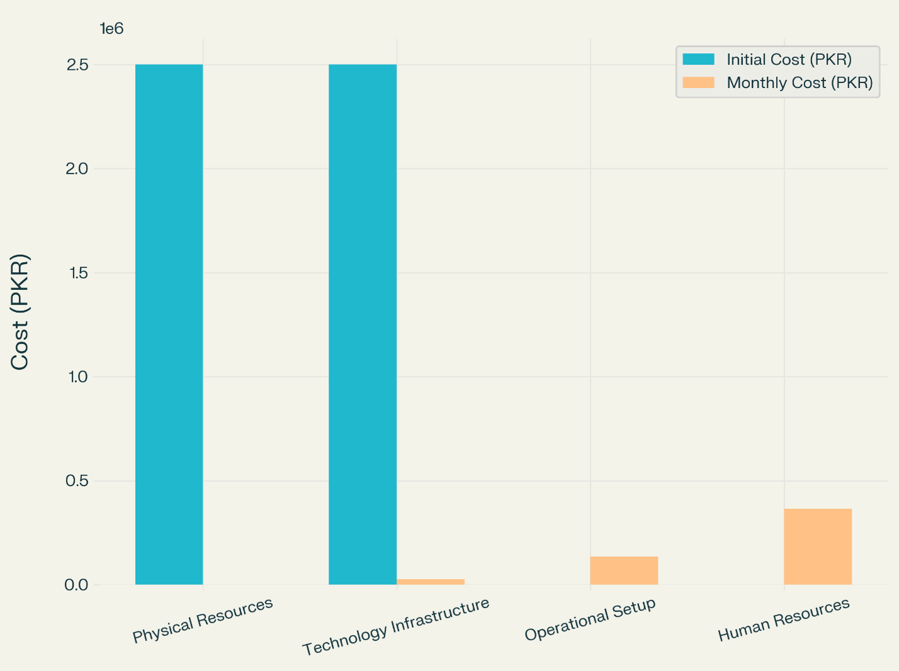

## 2. Resource Acquisition Plan

### A. Funding Options

#### 1. Equity Financing

* Angel Investors: Raise PKR 4 million in exchange for 40% equity

[[16]](https://www.seedventures.org/)

* Bahria University Incubator: Grant of PKR 1 million for 10% equity  
  [[17]](https://www.bahria.edu.pk/buic/incubator/)
* Co-founder capital: PKR 1 million from internal investment

#### 2. Debt Financing

* Small Business Loan: PKR 2 million   
  [[18]](https://www.sbp.org.pk/smefd/index.htm)
* Equipment Lease/Loan: PKR 1 million   
  [[19]](https://www.kamyabjawan.gov.pk/)

#### 3. Government Grants

* **NIC (National Incubation Center)**: PKR 1 million  
  [[20]](https://nicpakistan.pk/)
* **Kamyab Jawan Program**: Youth support up to PKR 500,000  
  [[21]](https://www.pmyp.gov.pk/)

#### 4. Bootstrapping Strategies

* Pre-sell storage packages (premium/monthly plans) Target: PKR 300,000
* Revenue-sharing partnerships with hotels/hostels
* Lean MVP approach to delay full-scale app development

### B. Potential Partners

#### 1. Space Partners

* Bahria University (confirmed beachhead) [[13]](https://bahria.edu.pk/)
* Hotels near airports and tourist areas: **Serena**, **PC**
* Commercial buildings with unused basement/parking areas or under utilized area.

#### 2. Technology Partners

* Local software houses (e.g., Systems Ltd., Techlogix)
* Payment Gateways: **Jazz Cash**, **EasyPaisa**  
  [[22]](https://www.easypaisa.com.pk/)

#### 3. Operations & Logistics

* Courier/logistics firms for portable lockers
* Security companies for 24/7 personnel
* Insurance providers: **TPL Insurance**, **EFU**

#### 4. Marketing Partners

* Tour operators and booking platforms (e.g., **Sastaticket.pk**)
* Student societies and university marketing cells
* E-commerce platforms (Daraz, Facebook seller communities)

**Potential Partners:**

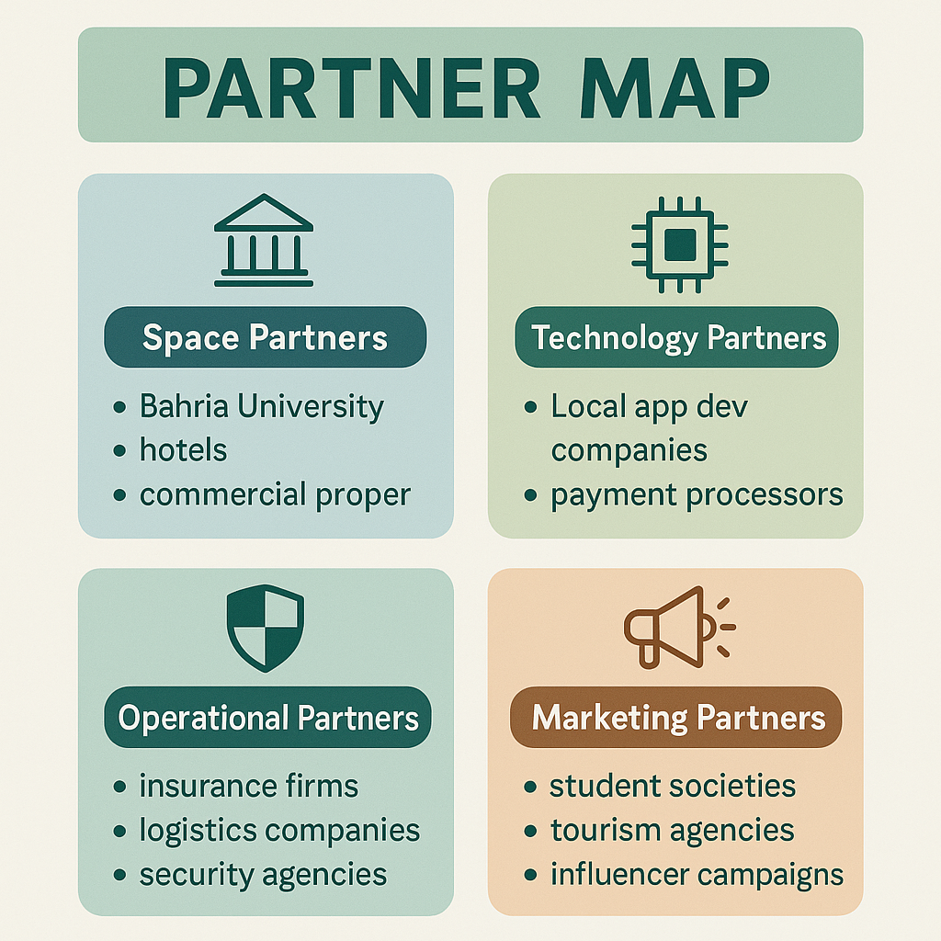

# Part IV: Marketing Plan – StoreEase

## 1. Target Market Segmentation

StoreEase focuses on three highly relevant market segments based on extensive customer validation.

### A. Students (Age: 18–24)

* **Demographics**: University students in urban areas (e.g., Lahore, Islamabad)
* **Psychographics**: Tech-savvy, value convenience and security, price-sensitive
* **Behavior**: Regularly carry laptops/books, no formal locker systems on campuses

**Why this segment?**  
Students are mobile throughout the day, often needing secure space between classes, during lunch breaks, or while participating in extracurriculars.  
[[6]](https://www.fccollege.edu.pk/)

### B. Hostel Residents (Age: 18–26)

* **Demographics**: Non-local students and interns living in rented accommodations
* **Psychographics**: Practical, responsible, limited space/resources
* **Behavior**: Require storage during semester breaks or hostel closures

**Why this segment?**  
Hostel shutdowns during holidays create repeat demand for medium-term, monthly storage solutions.

### C. Travelers (Age: 25–40)

* **Demographics**: Tourists, business travelers, seasonal visitors
* **Psychographics**: Digital first, mobile, prefer convenience over cost
* **Behavior**: Seek short-term storage after hotel checkout and before transit

**Why this segment?**  
They face a clear gap between checkout (11 AM) and departure (evening/night), needing secure, hourly storage.  
[[23]](https://www.thenews.com.pk/print/1010158-travel-and-tourism-sector-seeks-more-attention)

## 2. Marketing Strategies

### A. Digital Marketing

**Key Platforms:**

* **Facebook & Instagram**: Targeted ads to students and travelers
* **YouTube Shorts**: Demo videos of storage usage, customer testimonials
* **Google Ads**: Local keywords (e.g., *"temporary locker Lahore"*)
* **Email Marketing**: Deals, updates, and partnership outreach (universities, hotels)
* **SEO Strategy**: Blog content around *"secure storage for students"*, *"where to store luggage in Lahore"* for organic search

**Engagement Tactics:**

* **Influencer Campaigns**: Collaborate with student vloggers and travel bloggers
* **Referral Incentives**: App-based referral programs to drive organic sign-ups
* **Review Strategy**: Request reviews from happy customers on Google Play/App Store

[**[24]**](https://www.statista.com/statistics/1176107/pakistan-social-media-users/)

### B. Conventional Marketing

**Offline Tactics:**

* **Flyers & Brochures**: Handouts in hostels, university gates, bus terminals
* **Campus Events**: Orientation weeks, student society fairs, info booths
* **Hostel Collaboration**: Poster placements, onboarding talks with management
* **Radio or Local Cable Ads**: Run seasonal promotions during Eid, summer breaks, and tourism peaks

## 3. Branding Strategy

### A. Brand Personality

* **Friendly, secure, tech-smart, and youth-focused**
* Speaks in a simple, reassuring tone

### B. Brand Positioning

* **“Your safe space, anytime – Smart storage at your convenience.”**
* Positioned as a **student- and traveler-first**, mobile-led platform

### C. Brand Message

* **“Store smart. Travel light. "**
* **“Your campus storage companion.”**
* **“Your personal storage companion”**
* **“Less baggage. More life.”**

Focused on freedom, security, and flexibility

### D. Visual Identity



### E. Strategic Alignment

* Visuals and tone are tailored to **digital-native, safety-conscious youth**
* Consistent across **app, websites, flyers, and video content**
* Builds an identity that’s modern, safe, and easy to engage with

# Part V: Operations Plan – StoreEase

## 1. Product/Service Delivery Process

Since StoreEase is a **tech-enabled service platform**, its operations focus on **service delivery** rather than manufacturing. So the step-by-step operational flow for how StoreEase delivers its storage solution:

### Step-by-Step Service Delivery Process

1. **Customer opens mobile app/web portal**
   * Browse nearby available lockers/storage spots
   * Views prices, duration options, and security features
2. **Locker Booking & Payment**
   * Customer selects time slot and location
   * Pays via Jazz Cash/EasyPaisa/Debit card
   * Gets a unique QR code for locker access
3. **Drop-off**
   * Customer visit’s location
   * Scans QR code at smart locker/attended storage counter
   * Stores belongings; receives digital inventory receipt
4. **Storage Duration**
   * Storage is monitored via **24/7 CCTV**
   * Customer can track time or extend storage via app
5. **Pickup**
   * Customer returns and unlocks with QR/biometric
   * Item status confirmed via app
   * Feedback prompt is shown after pickup

**Flow Diagram:**

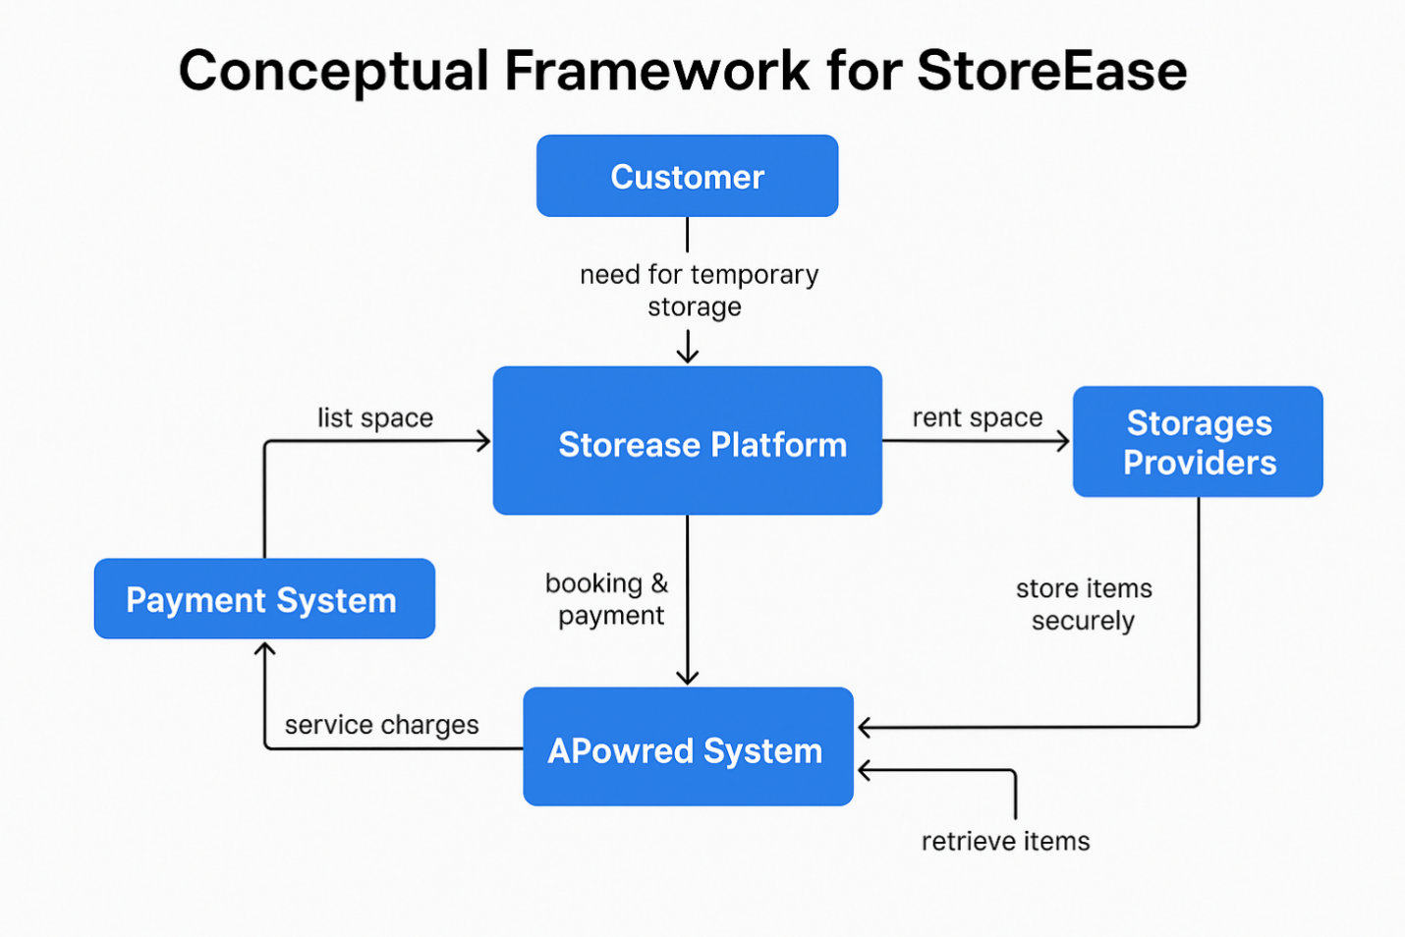

### Potential Bottlenecks & Challenges

| **Challenge** | **Risk** | **Solution** |
| --- | --- | --- |
| High booking demand at peak hours | No availability | Use AI-based dynamic scheduling & waitlist system |
| App crash/payment failure | Transaction interruption | Build robust, redundant backend + payment retry logic |
| Locker jams or access failure | Delays/frustration | On-site support staff + emergency override system |
| User doesn’t pick up on time | Overlapping bookings | Add grace period, auto-extension alerts, late fees |
| Storage misuse (hazardous items) | Legal/security risks | Include digital agreements & AI-powered item scan alerts |

## 2. Supply Chain Management

StoreEase doesn't manufacture but it manages a **multi-tier service-based supply chain** for lockers, software, maintenance, and location access. [1]

**Supply Chain Structure**

| **Tier** | **Role** | **Examples** |
| --- | --- | --- |
| **Tier 1** | Locker hardware & installation | Local metal fabricators, smart-lock tech suppliers |
| **Tier 2** | Tech infrastructure | App developers, cloud providers (AWS, Firebase) |
| **Tier 3** | Space partners | Hostels, universities, hotels |
| **Tier 4** | Operations vendors | CCTV suppliers, security guards, logistics teams |

### Sourcing & Distribution Process

1. **Sourcing Smart Lockers & Equipment**
   * Source locally (or import if cost-effective) based on size & budget
   * Partner with suppliers offering maintenance contracts
2. **Software Delivery**
   * Outsourced to a local dev house (via equity or retainer)
   * Built with microservices for scalable, modular updates
3. **Storage Deployment**
   * Install lockers in approved university/hostel areas
   * QR scanner & security system integrated on-site
4. **User Access & Delivery**
   * Service activated upon user booking → real-time availability mapping

### Potential Supply Chain Risks & Solutions

| **Risk** | **Mitigation** |
| --- | --- |
| Delay in locker supply or repairs | Maintain spare units in inventory for quick swaps |
| Software bugs during peak usage | Use cloud auto-scaling + dev support |
| Disputes with space providers | Draft MoUs with revenue-sharing terms & liability clauses |
| Delivery bottlenecks in setup | Pre-schedule installation batches with location-specific crews |

## 3. Customer Service Strategy

Customer service is **key to retention**, especially in a **trust-dependent business**-like storage.

### Customer Service Standards

| **Standard** | **Details** |
| --- | --- |
| Response Time | In-app/chat/email response within **2 hours** |
| Complaint Resolution | Issue resolved or escalated within **24–48 hours** |
| Refund/Compensation Policy | Available for valid storage failure cases |
| 24/7 Support | Chatbot for basic queries + human escalation available 9 AM–9 PM |

### Feedback & Support Channels

* **Mobile App Chat**: Chatbot for booking, extensions, FAQs
* **WhatsApp Business & Email**: Formal complaint or inquiry channels
* **Post-Booking Survey**: Optional feedback form via app/email
* **Call Support**: Helpline during working hours for elderly/less tech-savvy users

### Customer Satisfaction & Retention Tactics

* Loyalty Programs: Discounts for repeat use or referrals
* Trust Signals: Verified partner badges, user reviews, insurance options
* Transparency: Clear billing, real-time locker tracking
* Performance Monitoring: NPS (Net Promoter Score) after each booking
* Periodic App Updates: Feature improvements based on feedback

**Customer Service Workflow:**

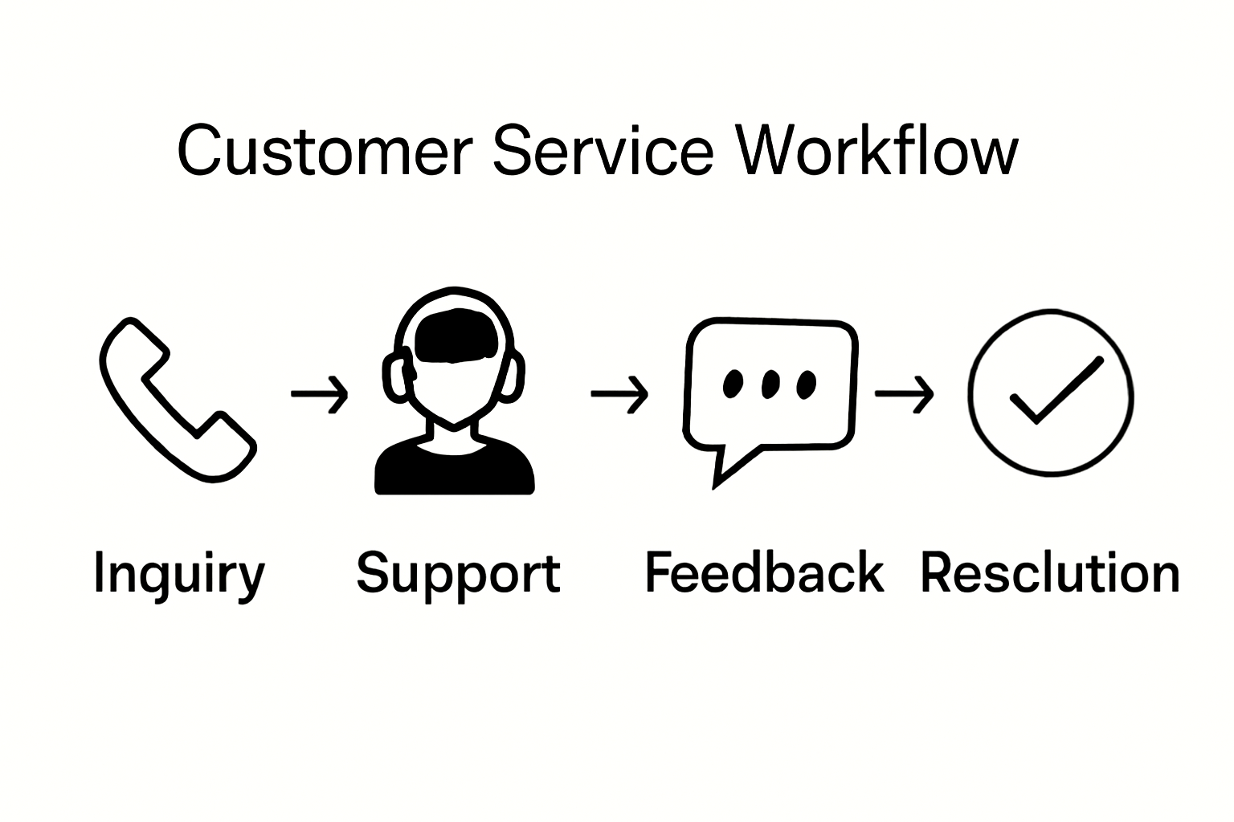

**Customer Satisfaction Funnel:**  
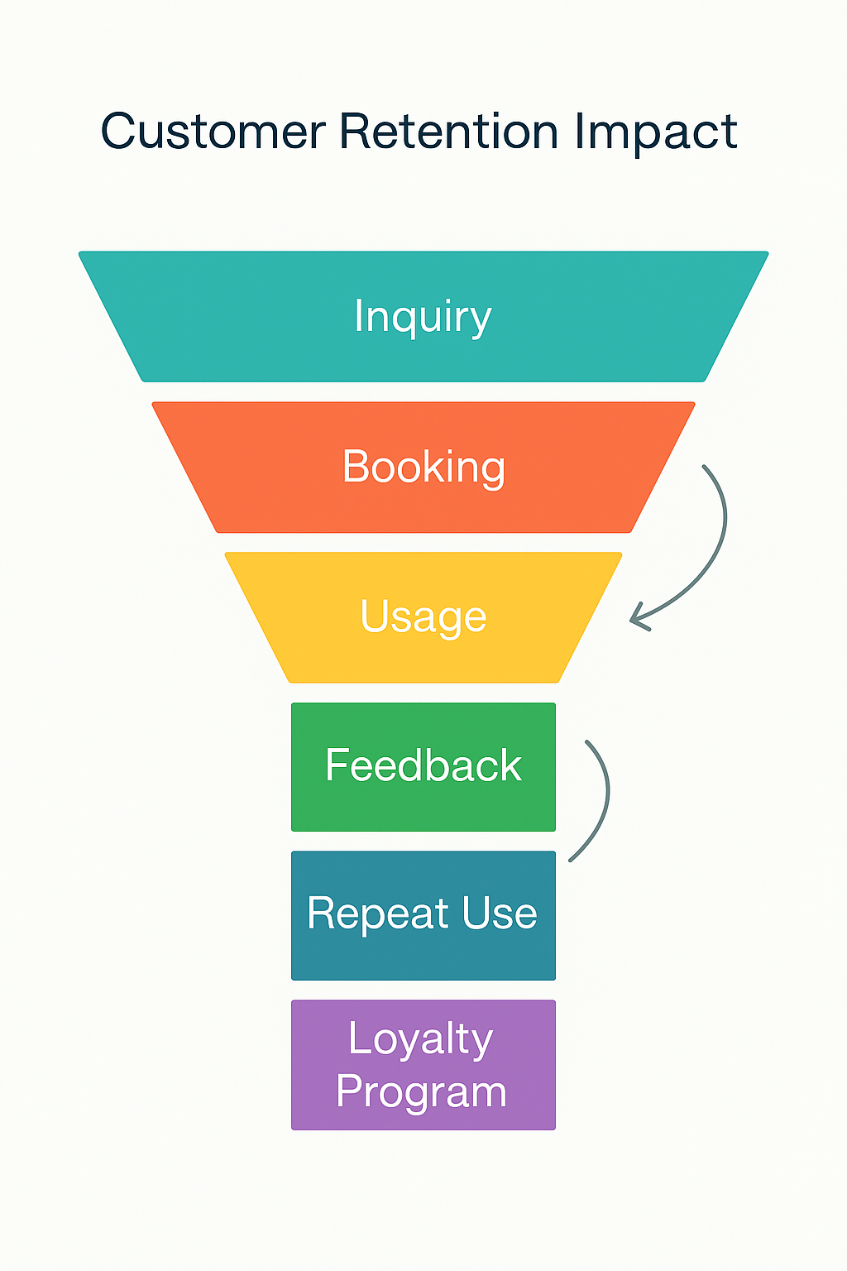

# Part VI: Financial Projections (Simplified) – *StoreEase*

## 1. Revenue Forecasts (First Year)

**Service Lines and Channels**

StoreEase generates revenue primarily through:

1. **Hourly Storage Rentals** (for travelers)
2. **Daily/Weekly Student Storage**
3. **Monthly Storage for Hostelers**
4. **Premium Add-ons** (insurance, priority locker access)
5. **Partner Commissions** (space providers)

**Estimated Monthly Revenue Breakdown**

| **Revenue Source** | **Price (Avg)** | **Units/Month** | **Monthly Revenue** | **Annual Revenue** |
| --- | --- | --- | --- | --- |
| Hourly Storage (Travelers) | PKR 200/session | 400 | PKR 80,000 | PKR 960,000 |
| Daily Storage (Students) | PKR 250/day | 300 | PKR 75,000 | PKR 900,000 |
| Monthly Locker (Hostelers) | PKR 3,000/month | 100 (during breaks) | PKR 300,000 | PKR 3,600,000 |
| Premium Add-ons | PKR 500/user | 150 | PKR 75,000 | PKR 900,000 |
| Partner Commissions | Avg. PKR 10,000/location | 10 | PKR 100,000 | PKR 1,200,000 |

**Total Projected First-Year Revenue**

**PKR 7,560,000**

Assumptions: Pilot operations at 2–3 key locations with steady monthly growth and 50–60% capacity utilization.

**Revenue streams by category, line graph of monthly revenue growth:**

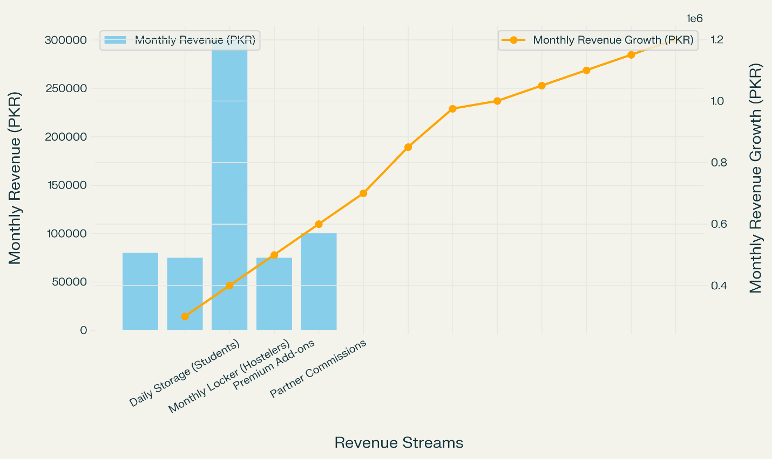

## 2. Expense Budget (First Year)

**Fixed Costs**

| **Category** | **Cost/Month** | **Annual Total** | **Justification** |
| --- | --- | --- | --- |
| Office Rent + Utilities | PKR 85,000 | PKR 1,020,000 | Small admin office + energy costs |
| Salaries (core team) | PKR 500,000 | PKR 6,000,000 | Tech, ops, marketing, support |
| Insurance | PKR 100,000/year | PKR 100,000 | Risk coverage for stored items |
| Cloud Hosting & App Maintenance | PKR 30,000 | PKR 360,000 | AWS/Firebase + app fixes |

**Variable Costs**

| **Category** | **Monthly Avg** | **Annual Total** | **Justification** |
| --- | --- | --- | --- |
| Marketing | PKR 150,000 | PKR 1,800,000 | Digital + offline campaigns |
| Locker Repairs & Replacements | PKR 20,000 | PKR 240,000 | Maintenance of storage units |
| Support Staff (field/security) | PKR 80,000 | PKR 960,000 | Operations across 2–3 sites |
| Logistics & Setup | PKR 50,000 (initially) | PKR 200,000 | Locker delivery and setup |

**Total Projected Expenses for Year 1**

* **Fixed Costs**: PKR **7,480,000**
* **Variable Costs**: PKR **4,200,000**
* **Total**: PKR **11,680,000**

**Pie chart of cost distribution (e.g., salaries, marketing, logistics):**

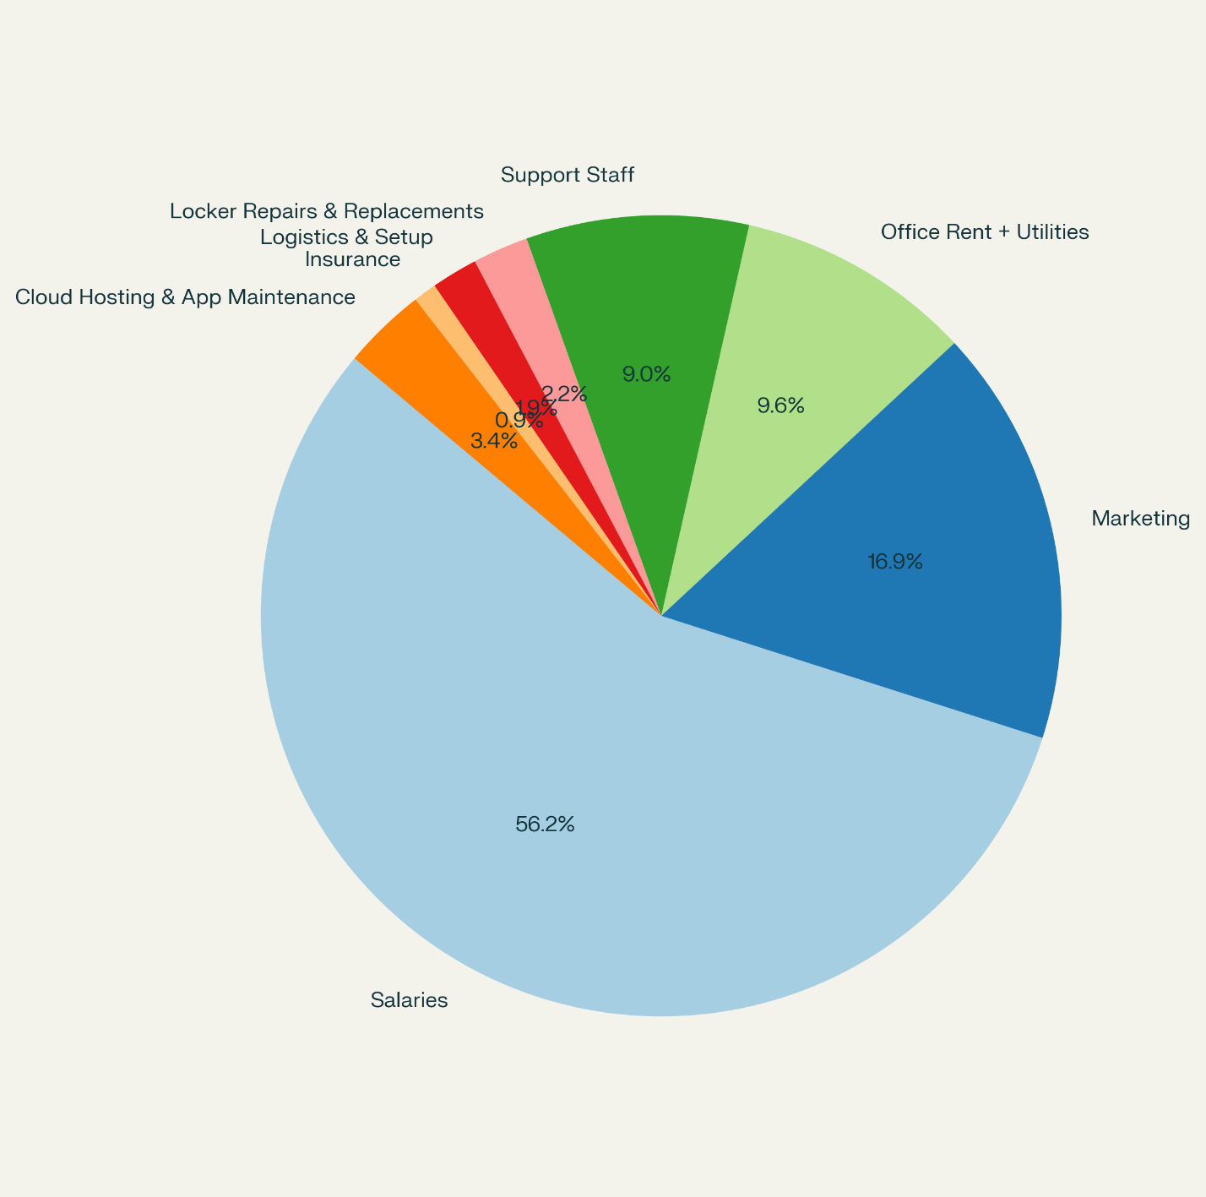

## 3. Break-even Analysis

**Break-even Point Calculation**

Let’s assume:

* **Average Revenue per Customer**: PKR 750
* **Average Monthly Fixed + Variable Costs**: PKR 973,333
* **Break-even Customers/Month** = Total Monthly Costs / Revenue per Customer  
  → PKR 973,333 ÷ 750 ≈ 1,298 customers/month

**Time to Reach Break-even**

| **Month** | **Users Targeted** | **Monthly Revenue** |
| --- | --- | --- |
| Month 1 | 400 | PKR 300,000 |
| Month 3 | 800 | PKR 600,000 |
| **Month 6** | **1,300+** | **PKR 975,000** **“BREAK-EVEN”** |
| Month 12 | 1,500+ | PKR 1,100,000+ |

**Conclusion:** StoreEase is projected to reach break-even in **6–7 months**, assuming active digital marketing, user retention, and 60% locker utilization.

**Tactics to Achieve Break-even**

* **Referral Bonuses** and Loyalty Discounts
* **Partner Promotions** with universities and travel agencies
* **Introductory Offers** in pilot locations
* **App Push Notifications** for repeat usage
* **Dynamic Pricing** for high-demand hours

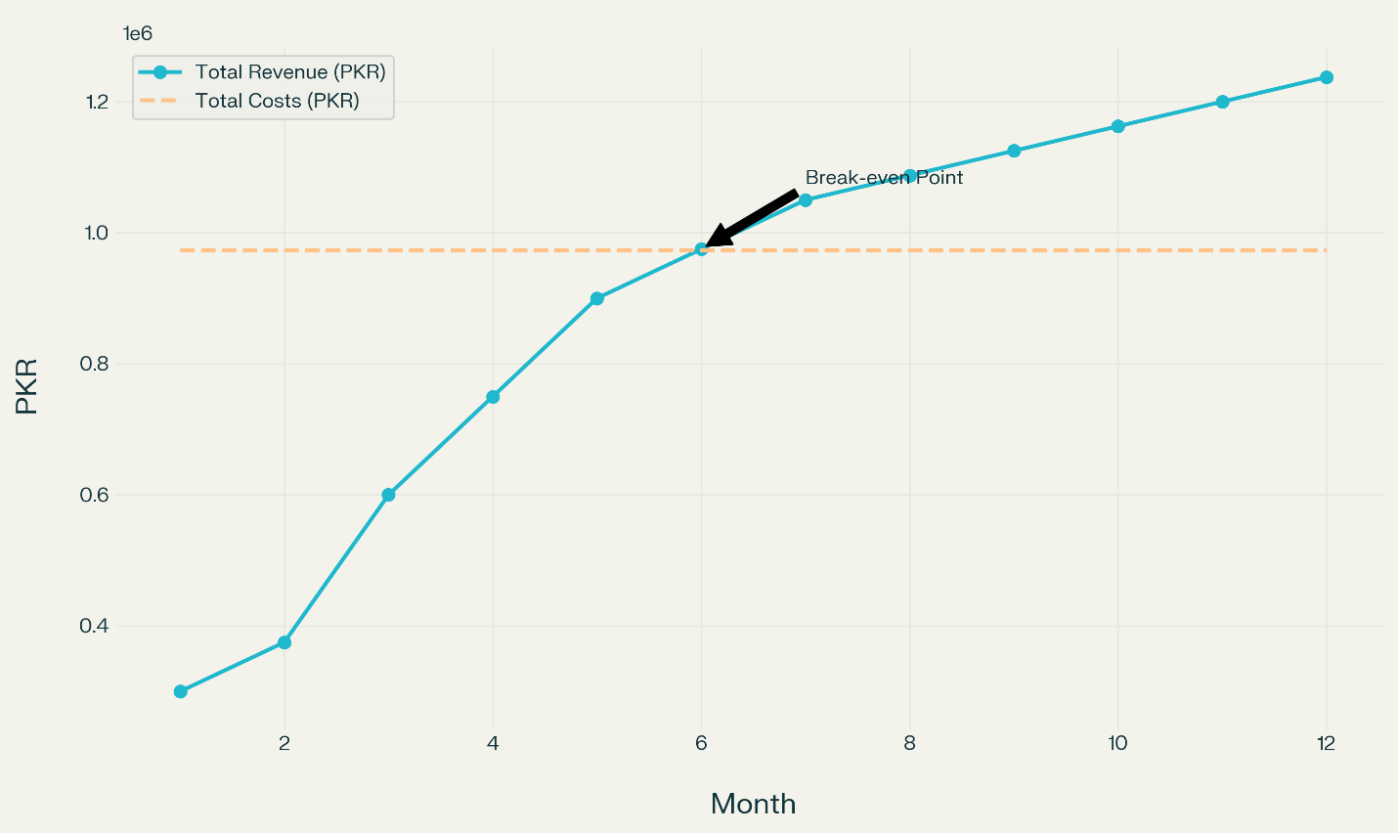**Break-even chart showing total revenue vs. total cost line intersection at Month 6:**

# References

* <https://eusafeluggage.com/luggage-storage-security-tips/>
* <https://london-post.co.uk/why-luggage-storage-services-are-the-future-of-travel/>
* <https://www.6wresearch.com/>
* <https://www.pta.gov.pk/en/telecom-indicators>
* <https://www.unbaggaged.com/post/safest-luggage-storage-service-tips>
* <https://www.fccollege.edu.pk/>
* <https://www.thenews.com.pk/>
* <https://www.camcode.com/blog/types-of-warehouse-storage-systems/>
* <https://ibrahimportacabin.pk/container-for-rent/>
* <https://boostsuite.com/launching-storage-business/>
* <https://www.pcmag.com/picks/the-best-business-cloud-storage-and-file-sharing-providers>
* <https://www.advisoryexcellence.com/warehousing-on-demand-the-benefits-of-temporary-storage-solutions/>
* <https://bahria.edu.pk/>
* <https://coworker.com/>
* <https://www.pitb.gov.pk/>
* <https://www.seedventures.org/>
* <https://www.bahria.edu.pk/buic/incubator/>
* <https://www.sbp.org.pk/smefd/index.htm>
* <https://www.kamyabjawan.gov.pk/>
* <https://nicpakistan.pk/>
* <https://www.pmyp.gov.pk/>
* <https://www.easypaisa.com.pk/>
* <https://www.thenews.com.pk/print/1010158-travel-and-tourism-sector-seeks-more-attention>
* <https://www.statista.com/statistics/1176107/pakistan-social-media-users/>